March
On
Harrisburg
9/27/2023

Parking and March Details

Instructions for March on THE DAY:
- We will travel down the stairs, right onto North 3rd Street.
- At the end of the block, we will turn right on North Street.
- Then proceed down the block and make a right onto Commonwealth Avenue.
- At this point we will break at the big fountain or continue down block to Walnut and make another right (May break for lunch on own)
  - Continuing down walnut will lead you back to North 3rd Street.
  - Another right and you will wind up back at the Capitol Stairs.

After lunch you may proceed with individual/group visits that you have already scheduled with legislators and/or drop your comment cards off to your legislator’s office.

Getting to the Capitol/Parking information:
http://www.pacapitol.com/plan-a-visit/getting-to-the-capitol.cfm

- Bus parking arrangements can be made by calling the State Bureau of Farm Show, (717) 787-5373; or, Harrisburg Parking Authority for City Island, (717) 255-3099.
- Automobile parking opportunities are conveniently located within a two-block radius of the State Capitol.
  - The closest parking garage is located at South St Garage, 220 South St, Harrisburg, PA 17101.
  - Next closest garage is at 214 Locust St, Harrisburg, PA 17101.
- See map below for visual details to include march route (green)
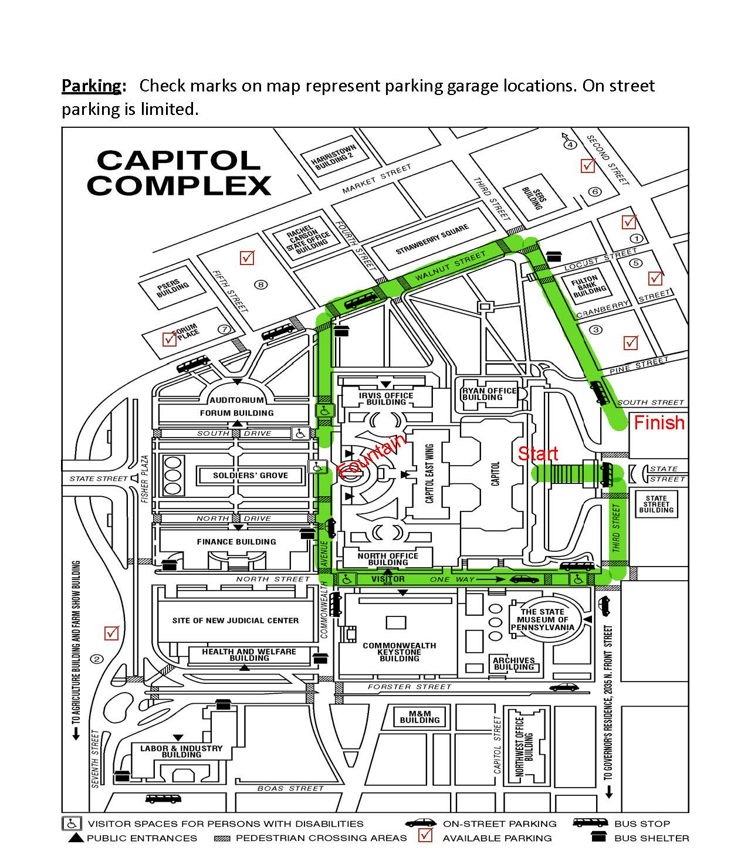
https://parkharrisburg.com/

